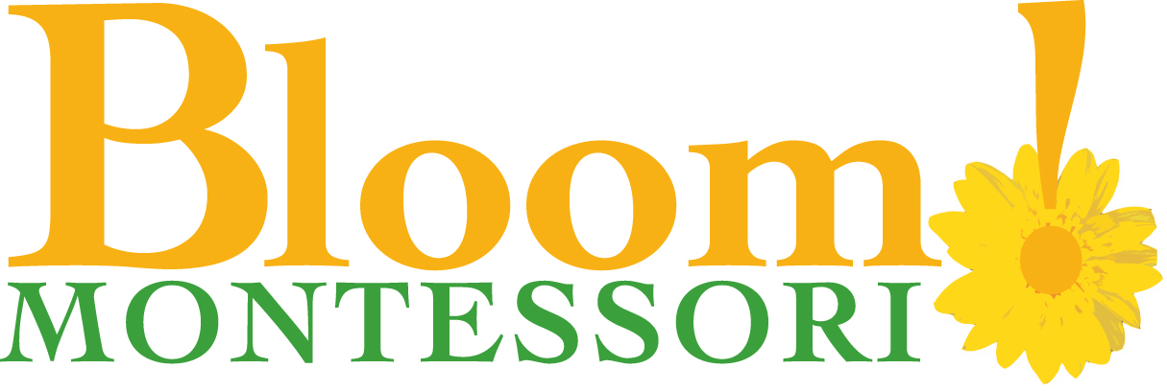

**2016-2017**

**New Student**

**Tuition and Fees**

**Calendar Year Term (12 Month Program): August 2016- July 2017**

**Hours Annual Tuition 12 Installments 12 Installments**

**By Direct Debit By Credit Card From Bank Acct. (Includes 3% finance charge)**

**___5 Full Time Days 8:00- 5:30 $ 11,760 $980 $1009**

**___4 Full Time Days $ 9,924 $827 $851**

**___3 Full Time Days $ 8,088 $674 $694**

Tuition is based on a place being held for the student. All tuition payments are made for the entire school year and are non-refundable. We have two options for payment: payment in full of the tuition balance at the beginning of the year, or monthly tuition payments made by direct debit/credit card authorization (by Chase® Merchant Services).

If you have additional questions about our tuition payment policies, payment options, or scholarships/financial aid, please contact the school at [admissions@bloommontessori.com](mailto:admissions@bloommontessori.com).